Name Class
Grade 8 End of unit 7 test
1 Work out the area of these circles. Use the π button on your calculator.
Round your answers correct to three significant figures (3 s.f.)
a radius = 7 m

[2]
b diameter = 26 cm

[2]
2 The diagram shows a semicircle.
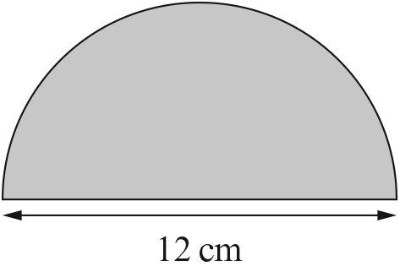
Work out, correct to one decimal place (1 d.p.):
a the area of the semicircle

[2]
b the perimeter of the semicircle.

[3]

3 Work out the radius of a circle with area = 42 cm².
Give your answer correct to two decimal places (2 d.p.)

[3]
4 Work out the area of these compound shapes. Give your answers correct to one
decimal place (1 d.p.)
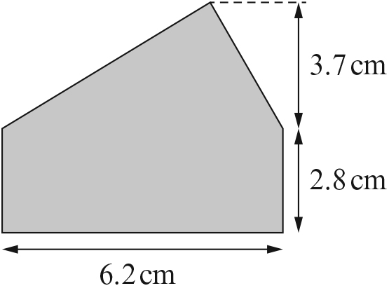
a ______________________________________________
______________________________________________
______________________________________________
______________________________________________ [3]

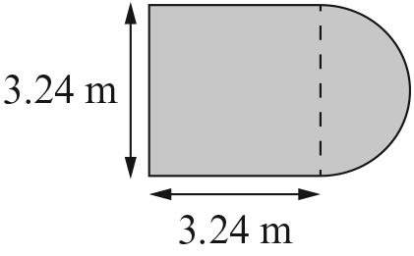
b ______________________________________________
______________________________________________
______________________________________________
_______________________________________________ [3]
5 The diagram shows three circles cut out from a rectangle.
The diameter of each circle is 8 cm.
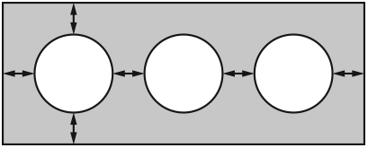
The distances shown by the arrows are 2 cm.
Work out the shaded area. Give your
answer correct to three significant figures (3 s.f.)
_________________________________________________________________________
_________________________________________________________________________
_________________________________________________________________________
_________________________________________________________________________
_________________________________________________________________________ [5]

6 a Write these capacities in order of size, starting with the smallest.
5 centilitres

5 nanolitres

5 microlitres

5 millilitres

5 litres

5 kilolitres

smallest:

largest: [4]

b Write each of the capacities in part a using only the correct letters for the units,
not words. For example, write 5 centilitres as 5 cL.
smallest:

largest: [1]
7 A store sells four items with different memory sizes.
A Memory: 32 GB B Memory: 256 MB C Memory: 2 TB D Memory: 512 KB
Write the items in order of memory size, from the smallest to the largest.

[2]
[Total: 30 marks]

END OF TEST

